TRANS LINGUA – AI POWERED MULTILANGUAGE TRANSLATOR

INTRODUCTION

Project Overview
The project titled “TransLingua – AI-Powered Multi-Language Translator” is developed as part of an academic / internship learning program. The primary objective of this project is to overcome language barriers using modern Artificial Intelligence technologies.
In today’s globalized world, communication across different languages has become common in education, business, travel, and digital platforms. However, language differences often result in misunderstanding and reduced efficiency. TransLingua provides an intelligent, AI-driven solution that enables users to translate text accurately between multiple languages.
The application accepts user input, processes it using Google Gemini Generative AI, and displays the translated output through a simple and interactive web interface built using Streamlit.

Purpose
Thepurpose of this project is to apply theoretical knowledge of Artificial Intelligence and Machine Learning to develop a practical, real-world application. The project enhances understanding of API integration, prompt-based AI systems, and secure application development.

Problem Statement
In the modern digital era, people from different regions communicate frequently. However, language barriers remain a major challenge when users are unable to understand foreign languages. Manual translation methods are time-consuming and error-prone, while many existing tools are complex or inaccessible.
There is a need for a simple, accurate, and AI-powered language translation system that can assist users in understanding content written in different languages.

Empathy Map Canvas

User Thoughts
- Wants to understand content in another language
- Expects accurate and fast translation User Feelings
- Frustrated when unable to understand foreign text
- Confident when translation is quick and correct User Actions
- Uses online translators
- Tries manual translation Pain Points
- Language barriers cause confusion
- Manual translation consumes time

User Needs
- Accurate AI-based translation
- Easy-to-use interface

Brainstorming
Different approaches such as rule-based translation, dictionary-based translation, and AI-powered translation were analyzed. AI-based translation was selected due to its scalability, accuracy, and ability to understand context.

Customer Journey Map
The user opens the application, enters text, selects source and target languages, and clicks the translate button. The system processes the input using AI and displays the translated output instantly.

Solution Requirements

Functional Requirements
- Accept user text input
- Translate text between languages
- Display translated output

Non-Functional Requirements
- User-friendly interface
- Fast response time
- Secure API key handling
- Reliable translation output

Data Flow Diagram
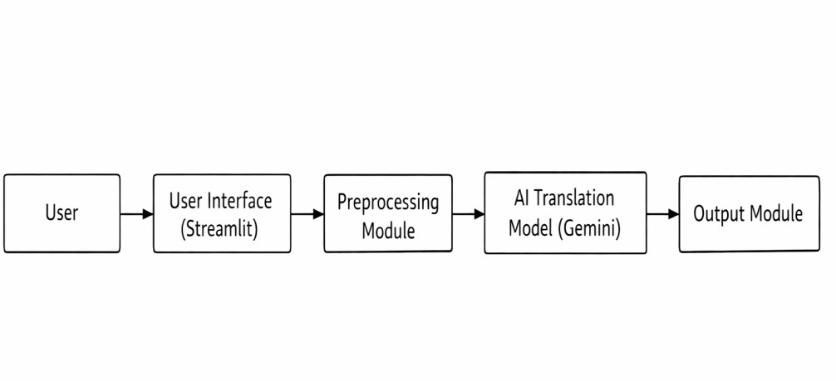

Technology Stack
- Programming Language: Python
- Framework: Streamlit
- AI Library: Google Generative AI (Gemini)
- Environment Management: python-dotenv
- Tools: VS Code, Git, GitHub

Problem–Solution Fit
The proposed system addresses communication challenges caused by language barriers by providing an automated translation solution. AI-based translation eliminates manual effort and improves communication efficiency.

Proposed Solution
The application allows users to input text, select languages, and receive translated output using AI. The system is designed to be simple, efficient, and scalable.

Solution Architecture
- User Interface (Streamlit)
- Preprocessing Layer
- AI Translation Engine (Gemini)
- Output Display Module

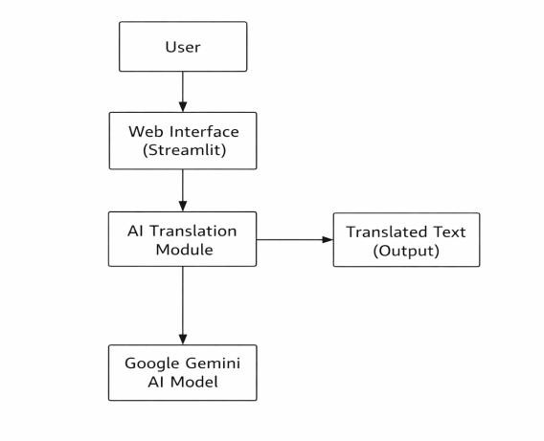

PROJECT PLANNING AND SCHEDULING
The project was completed using a phased approach:
- Requirement Analysis
- System Design
- Application Development
- Testing
- Documentation
Phase | Activity | Duration
Phase 1 | Requirement Analysis | 3 Days
Phase 2 | System Design | 3 Days
Phase 3 | Development | 7 Days
Phase 4 | Testing | 4 Days
Phase 5 | Documentation | 3 Days

FUNCTIONAL AND PERFORMANCE TESTING

Functional Testing
- Input validation
- Language selection verification
- API integration testing
- Output display verification

Performance Testing
- Response time evaluation
- Stability testing
- Multiple request handling

RESULTS
The TransLingua application successfully translates text across multiple languages. The system provides accurate translations with minimal response time and an intuitive user interface.
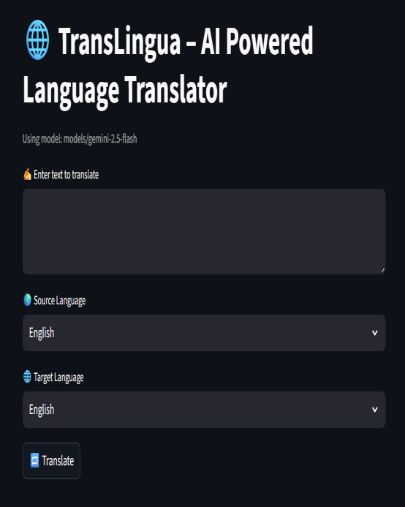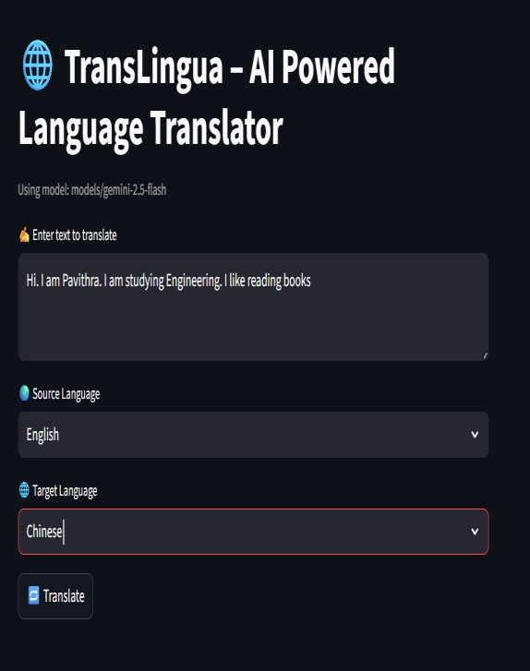

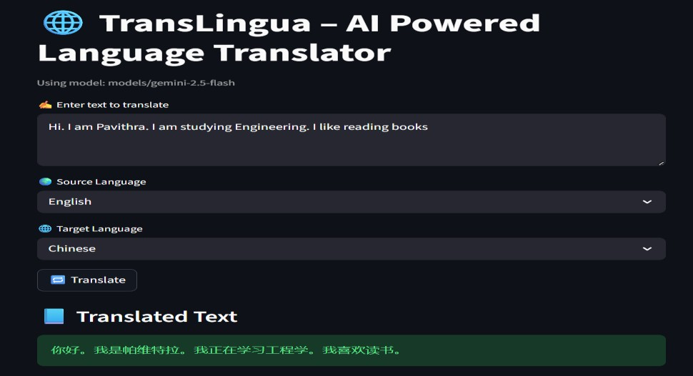

ADVANTAGES AND DISADVANTAGES

Advantages
- Easy-to-use interface
- Supports multiple languages
- AI-powered accurate translation
- Secure API handling
- Scalable design

Disadvantages
- Requires internet connection
- Depends on Gemini API availability
- Performance depends on network speed

CONCLUSION
The TransLingua project demonstrates the effective use of Generative AI to solve language barrier problems. The integration of Streamlit and Google Gemini AI provides a practical and efficient translation solution. The project fulfills all objectives and serves as a valuable learning experience.

FUTURE SCOPE
- Automatic language detection
- Voice-based translation
- Support for more languages
- Cloud deployment
- Mobile application version

APPENDIX

Version Control
The project source code is maintained using GitHub, ensuring proper version control and collaboration.

Security Implementation
- API keys stored using environment variables
- .env file excluded using .gitignore
- No hardcoded credentials

References
- Google Gemini Generative AI Documentation
- Streamlit Documentation
- Python Official Documentation

